Transposable elements
A major variation in nearly all genomes is caused by Transposable elements (TEs), also known as "jumping genes," which are DNA sequences that move from one location on the genome to another. The mark of a transposon is that it does not utilize an independent form of element like phage or plasmid but directly hops from one site to another. Often transposons carry additional sequences to new sites and thus result in genome restructuring leading to mutation. Transposons have been identified in almost all the living organisms that include bacteria, fungi, protists, plants and animals.
Transposons that mobilize via DNA are widespread in both prokaryotes and eukaryotes. Each transposon carries genes that code for enzyme activities required for its own transposition, although it may also require ancillary functions of the genome in which it resides like DNA polymerase or DNA gyrase.
Transposable elements of all kinds can promote rearrangements of the genome directly or indirectly:
- Transposition event itself may cause deletions or inversions or lead to the movement of a host sequence to a new location.
- Transposons serve as substrates for cellular recombination systems by functioning as portable regions of homology: two copies of a transposon at different location may provide sites for reciprocal recombination.

Insertion-Sequence (IS) Elements
It is the genetic element capable of moving around the genome. It integrates into the chromosome at locations with which it has no homology, thereby distinguishing it from recombination.
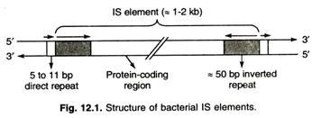
Composite transposons
When two IS elements integrate near each other, they trap the DNA in between to form a transposon. The DNA sequence between these two elements also behave like a transposon which otherwise has no role in transposition. Generally, this DNA sequence encodes antibiotic resistance genes.
Transposition of composite transposon occurs because of the function of the IS elements they contain. One or both IS element supplies the transposase. The inverted repeats of the IS elements at the two ends of the transposon are recognized by transposase to initiate transposition
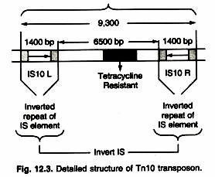

Non-composite Transposons:
They like composite transposons, contain genes such as those for drug resistance. Unlike composite transposons, they do not terminate with IS elements. However, they do have the repeated sequences at their ends that are required for transposition. The genes for transposition are in the central region for non-composite transposons.
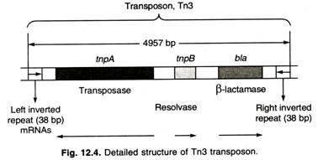
Replicative transposons
These types of transposons are replicated before transposition. An enzyme known as transposase helps in the insertion of one copy to a new site while another copy remains at the original site. This insertion is facilitated by another enzyme resolvase encoded by the DNA sequence on such transposons. It is only present in prokaryotes. Examples Tn3 and Mu phages.
Non-replicative transposons
Transposon is excised from the original position and inserted to another position in the genome. The target site is cleaved and ligated after the integration of the transposon. They are also called as excisive transposons. For example, IS elements and composite transposons in bacteria. Cut and paste transposons are found in both prokaryotes and eukaryotes. This method of transposition is also known as conservative mechanism of transposition since the transposon cuts itself and move to another position, so no new copy of transposon is created unlike replicative transposons.
MU transposon
The bacteriophage Mu is a transposable element. It uses transposition to insert into the E. coli chromosome after infection and form Mu lysogens. The low target-site selectivity of insertion results in insertion mutations at many different locations, reflecting the disruption of many different genes, leading to a "mutator" ("Mu") phenotype.
Mu also uses transposition to replicate its DNA during lytic growth; multiple rounds of transposition result in the formation of multiple Mu-specific replication forks, and DNA replication from these forks produces multiple copies of Mu.
Understanding Mu has played a key role in the dissection of the control and mechanism of transposition. Mu has also been key in studying the mechanism of transposition, because Mu transposition occurs at a high frequency during lytic growth, rather than the low frequency observed for most other elements.
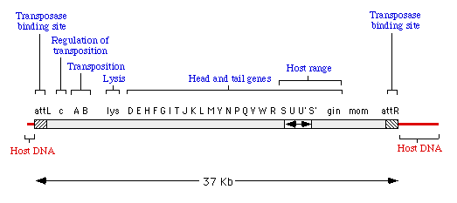
- The A and B gene products encode transposase -- the A protein is required for all transposition events, but the B protein is only required for replicative transposition events.
- Expression of the transposase genes is repressed by the c gene product.
- Transposition requires the two ends of Mu, labeled attL and attR (sometimes called MuL and MuR).
- When Mu DNA is packaged into a phage head it includes about 50-150 bp of host DNA at the left end and a variable amount of host DNA on the right end. Each Mu is packaged from a different site in the host genome, so the host DNA on the ends of Mu is unique in every different phage head.
The life cycle of phage Mu is shown in the cartoon below.
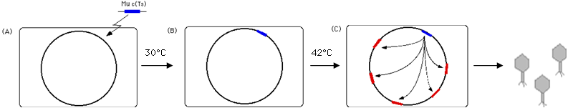
(A) When Mu infects a sensitive host, the linear DNA enters the cell and the Mu DNA (i.e. not including the variable sequences of DNA acquired from the previous host) is inserted into the recipient genome via a non-replicative, "cut and paste" mechanism.
(B) Lysogens of wild-type Mu are quite stable and are not induced by UV or other DNA damaging agents. However, derivatives of Mu with a temperature sensitive repressor -- Mu c(Ts) -- can be induced by shifting the lysogen to 42⁰ C.
(C) When the repressor is inactivated, the A and B proteins are expressed and Mu transposes by a replicative mechanism to 50 - 100 new sites on the chromosome. Meanwhile, late phage gene products are made (including phage heads, tails, lysis proteins, etc). The phage DNA is packaged by a headful mechanism, beginning by cutting the dsDNA in host sequences located about 100 bp from the left end of Mu. The length of Mu DNA is about 37 Kb and about 39 Kb are packaged into each head, so about approximately 2 Kb of host DNA is included on the right end of the packaged DNA. After assembly of the phage, the host is lysed, releasing 50-100 phage particles.
P elements
P transposable elements were discovered in Drosophila as the causative agents of a syndrome of genetic traits called hybrid dysgenesis.
These are small transposons with terminal 31-bp inverted repeats, and the element generates 8-bp direct repeats of target DNA sequences upon insertion.
The complete element is 2907 bp and is autonomous because it encodes a functional transposase.
Incomplete members P elements have lost the transposition ability because the transposase has been mutated. But if a complete (autonomous) element exists in the same cell as an incomplete (non- autonomous) element, then the incomplete element can transpose because of the presence of the transposase in the cell.
One of the most important uses of P elements since their discovery has been P-element-mediated germ line transformation. The method makes use of the fact that P elements normally only transpose in germline cells and that a P element carrying a foreign gene can be mobilized in trans using a source of transposase.
This relationship among complete and incomplete P elements is similar to that of the Ac/DS family in corn.
The phenomenon known as hybrid dysgenesis results from the mobilization of DNA sequences called P elements in Drosophila embryos. When a sperm from a P-carrying strain fertilizes an egg from a non-P-carrying strain, the P elements transpose throughout the genome, usually disrupting vital genes.

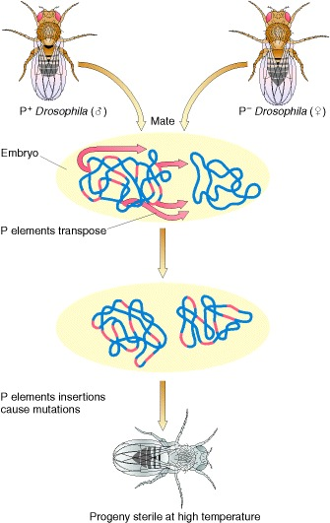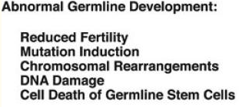
Ac/Ds Activator/Dissociation Transposable Element
The phenotypic consequence of Ac/Ds transposable element includes mosaic colors in kernels and leaves in maize.
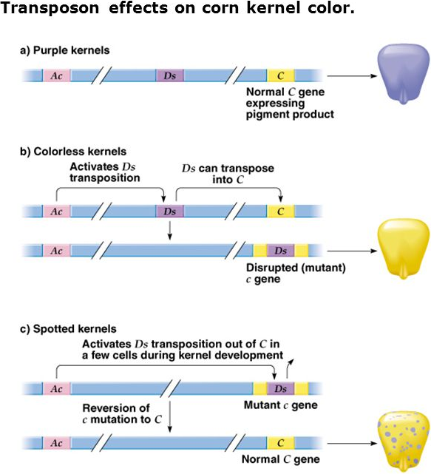
The Ac/Ds transposable element system was the first transposable element system recognized in maize.The Ac Activator element is autonomous, whereas the Ds Dissociation element requires an Activator element to transpose. Ac was initially discovered as enabling a Ds element to break chromosomes. Both Ac and Ds can also insert into genes, causing mutants that may revert to normal on excision of the element.
The following lists the molecular features of the Ac/Ds system of maize.
- Ac is 4563 bp in length
- Ac contain essential 11-bp inverted repeats at the ends
- Ac encodes a 3.5 kb mRNA that is translated into a 92 kDa transposase protein, 101 N-terminal amino acids not required for transposition, about 200 bp on each end of element necessary for transposition transposase binds to the hexamer AAACGG
- 8-bp direct repeats of target DNA are generated
- footprints (residual DNA sequences) are often left behind after the element is excised
- Ds are truncated versions of Ac; these can lack a transposase or the inverted repeat

Ty retrotransposons
Ty elements in yeast Ty (for transposon yeast) elements are a family of common retrotransposons found in yeast; many yeast cells have 30 copies of Ty elements.
Ty elements belong to the retrotransposons group. The abbreviation “Ty” stands for “Transposons of yeast”. Saccharomyces cerevisiae retrotransposons and retroviruses are often compared because of the similarity between their life cycles and their mechanism of integrating cDNA into host genomes. Ty elements generate more copies of themselves for inserting in the hostcell genome. Ty genome contains two genes: TYA1 and TYB1, which correspond to the gag and pol genes of retroviruses, respectively (3). As with certain retroviral pol genes, TYB1 expression requires programmed ribosomal frameshifting (6). Ty mRNA is transcribed and processed in the nucleus and then transported to the cytoplasm, where it is translated into Gag and Gag-Pol proteins (8). The Ty elements of Saccharomyces cerevisiae produce virus-like particles (VLPs), which never leave the cell (20). During the assembly process, Ty1 RNA is packed within the VLPs and subsequently reverse-transcribed into a full-length cDNA. In the final step of transposition the cDNA is integrated into a new site in the host genome, and the cycle can begin anew by transcribing the newly transposed element.
Features of TY elements
- about 35 copies in the haploid yeast gene
- has an about 340 bp sequence at both ends in a direct orientation; these are called long terminal repeats or LTRs
- resemble eukaryotic retroviruses; because they lack some of the retroviral functions they are considered to be primitive retroviruses; because of their similarities they are called retrotransposons
- transposition involves an RNA intermediate that is generated by transcription of the TY element; a reverse transcriptase (encoded by the TyB gene of the element) makes a DNA copy of the element which is then inserted into a new site in the yeast genome
